CLASS ACTIVITY 11.10.2024-review
1. Draw ERDs for each of the following. Draw softboxes, relationship lines, and labels for each relationship in both directions.
a) Each garment must have one and only one price. Each price may be for one or more garments.
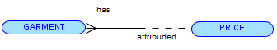
b) Each airline coupon must be used for one and only one destination. Each destination may be visited with one or more coupons.
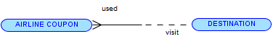
c) Each automobile must use one and only one tire size. Each tire size may be used by one or more automobiles
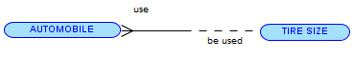
d) Each person must be of one and only one blood type. Each blood type may classify one or more persons.

e) A person may be on one or more junk-mail lists. Each junk list may contain one or more persons. Each honor student must attend one and only one school.

f) Each fingerprint must belong to one and only one person. Each person must have one and only one fingerprint.


2. Provide two examples for each relationship type:
a) One-to-one


b) One-to-many


c) Many-to-many


3. Identify the possible Entities, their Attributes and the relationships between the entities from each of the following scenarios. Construct your ERD following diagramming convention.Write the sentences for each relationship, in both directions.
a) A School/University has many Departments which offer courses to students in a given academic session. Each of these courses is taught by a teacher. We keep a record of the teacher’s first name, last name, address, phone number, and email address. Students enroll for different courses in an academic session. Besides the registration details, the parent information of the student also needs to be maintained by the University/School.
The Department maintains the student’s attendance details which would decide the eligibility of the student to take up the exams for that academic session. For each academic session, exams are conducted and the results are shared with the student within a stipulated period of time. The Department also maintains a log of the teacher login and logout time for their reporting needs.
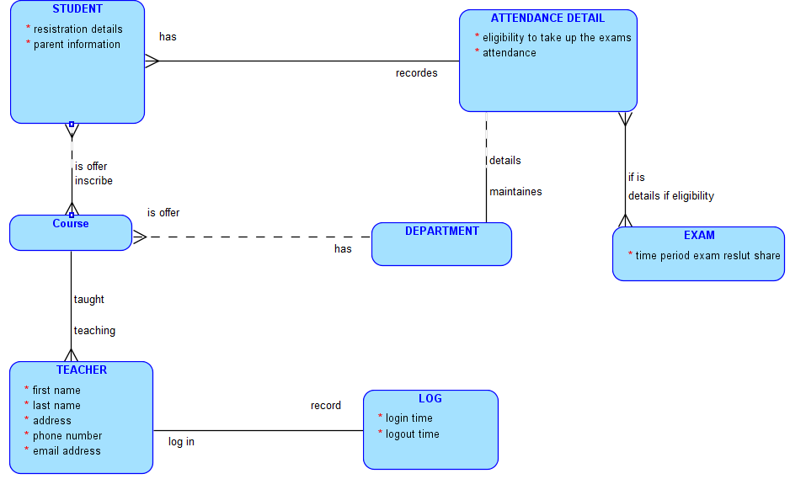

Attendance Detail – Exam
Each Attendance Detail must have one or more eligibilty autorization for Exam. Each Exam must have one or more eligibilty autorization for Attendance Detail
Department - Attendance Detail
Each Department must have one or more Attendance Detail. Each Attendance Detail must have one or more Department.
Course - The student
Each Course may have one or more student. Each student must have one or more Course.
Course – Department.
Each Course may have one and only Department. Each Department may have one or more Course.
Teacher – Log
Each Teacher must have one and only one Log to log in. Each Log must have one and only one Teacher to record.
Course – Teacher:
Each Course may have one and only Teacher. Each Teacher may have one or more Course.
The student – Attendance Detail:
Each student must have one and only one Attendance Detail. Each Attendance Detail must have one or more student.

b) To subscribe to various magazines, people must provide their name, address, and a telephone number. Each magazine is identified by title, volume number and publication date. Subscribers sign a contract for a certain period specified by the start date of the subscription and the final date. Of course, a person can subscribe to several magazines at the same time.
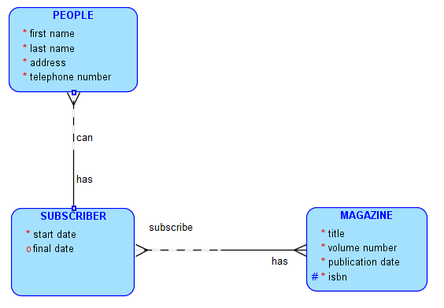
People – Subscriber:
Each People must have one and only one Subscriber. Each Subscriber Department may have one or more People.
Subscriber – Magazine:
Each Subscriber must have one or more Magazine. Each Magazine may have one or more Subscriber.

